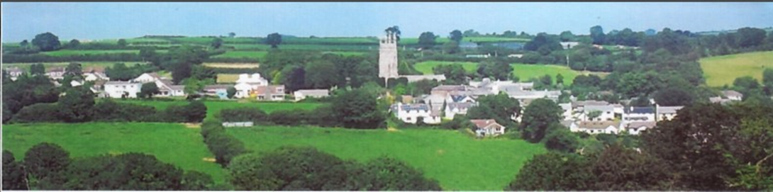
NORTH HILL PARISH COUNCIL
TENDER OPPORTUNITY
North Hill Parish Council are seeking to engage a contractor for the following:
This tender is to complete works for a path to be created leading from the car park at the back of the village hall in North Hill, to the cemetery gates, a length of approximately 44 meters in length. The work will include the removal of a section of bank and top soil, levelling and finishing of the path. The successful contractor will be asked to provide detailed information on how they are going to carry out the work safely with minimal risk to themselves and others. Public Liability Insurance will be required. The works are to be completed in the spring / summer of 2026.
The clerk or Councillors are happy to meet on site with any individuals who wish to discuss the works in more detail.

Please contact clerk@northhillparish.org.uk for the full job specification.

Lena Batten, Clerk to North Hill Parish Council
9 Highbury
Rilla Mill
PL17 7PH
Telephone 07399189548.
Closing date for applications: 20th March 2026.

